

USER REQUIREMENTS DOCUMENTATION
Project: MenCare Health Hub
Men’s Urological & Reproductive Health Education & Healthcare Information Platform
Version: 1.0
Target Users: General Public and System Administrators
Project Level:
───

1. Introduction
1.1 Purpose
This document defines the requirements of the people who will interact with MenCare Health Hub. It describes what users expect the system to do, the information they need, and how they should be able to interact with the platform.
The document focuses on user needs and expectations rather than the technical implementation of the system.

───

2. Target Users
MenCare Health Hub will have two main categories of users:
1. General Users
These are people who want to learn about men's urological and reproductive health or find relevant healthcare services.
They may include:
- Men seeking general health information
- Young adults seeking health education
- Individuals experiencing health-related symptoms
- People seeking information about STI prevention
- People looking for relevant healthcare facilities
- Students and other users interested in health
education
2. Administrators
Administrators are authorized users responsible for maintaining the information available on the platform.
They will manage:
- Health conditions
- Health categories
- Health facts
- Myth-versus-fact information
- Healthcare facilities

───

3. General User Requirements
UR-01: Access the Platform
The user should be able to access MenCare Health Hub using a standard web browser.
The user should not be required to create an account to access general educational content.

───

UR-02: View the Homepage
The user should be able to access a homepage that clearly explains:
- What MenCare Health Hub is
- The purpose of the platform
- The type of health information available
- How the platform can help users
The homepage should provide easy access to the
major sections of the system.

───

4. Health Education Requirements
UR-03: Browse Health Topics
The user should be able to browse available men's health topics.
The topics should be organized into categories such as:
- Prostate Health
- Urinary Health
- Sexual Health
- Sexually Transmitted Infections

───

UR-04: View Health Conditions
The user should be able to select a health condition and view detailed educational information.
Initially, the platform should provide information about:
- BPH
- Prostatitis
- UTI
- Urethritis
- Chlamydia
- Gonorrhea
- Genital Herpes

───

UR-05: Understand a Condition
When viewing a condition, the user should be able to easily find information about:
- What the condition is
- Its causes
- Common symptoms
- Risk factors
- Prevention
- General diagnosis
- Treatment overview
- When to seek medical attention
- Related conditions
The information should be presented in simple and understandable language.

───

5. Symptom Awareness
Requirements
UR-06: Explore Symptoms
The user should be able to browse common symptoms related to men's urological and reproductive health.
Examples include:
- Pain or burning during urination
- Frequent urination
- Difficulty starting urination
- Weak urine stream
- Blood in urine
- Genital discomfort
- Unusual genital discharge

───
UR-07: Understand Possible Associations
When the user selects a symptom, the system should provide general educational information about conditions that may be associated with the symptom.
For example:
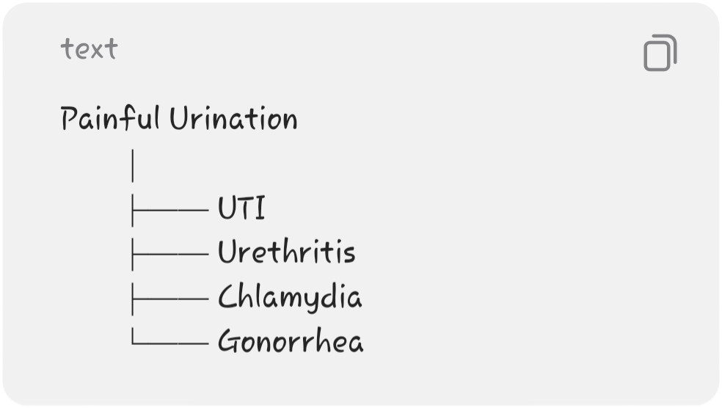
The system should clearly explain that:
A symptom may have several possible causes and does not mean that the user has a particular disease.

───

UR-08: Know When to Seek Help
The user should be able to access information explaining when it may be appropriate to consult a healthcare professional.
Examples may include:
- Persistent symptoms
- Painful urination
- Unusual discharge
- Persistent genital discomfort
- Repeated urinary problems
- Other concerning symptoms
The platform should direct users with urgent concerns toward appropriate emergency or professional healthcare services.

───

6. Search Requirements
UR-09: Search Health Information
The user should be able to search for health information using keywords.
For example:
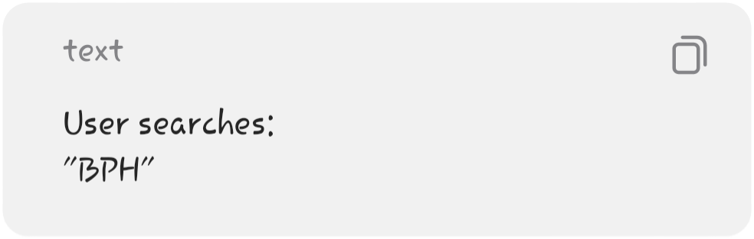
The system should return relevant information about:
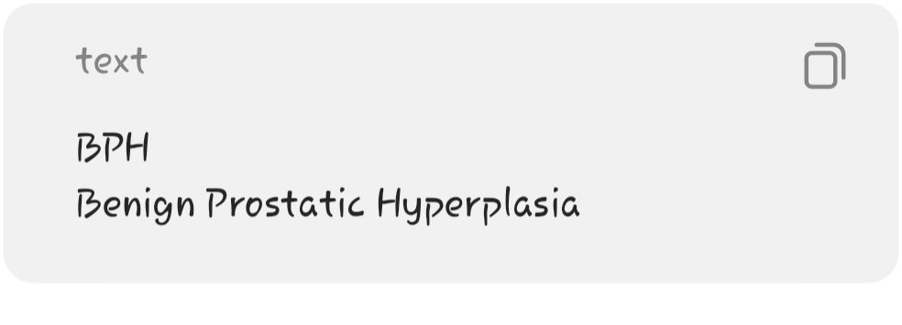


───

UR-10: Search Using Symptoms
Users should also be able to search using symptom-related keywords.
For example:

- The system may return relevant topics such as:
- UTI
- Urethritis
- Chlamydia
Gonorrhea

───

UR-11: Filter Health Topics
The user should be able to filter health topics by category.
For example:
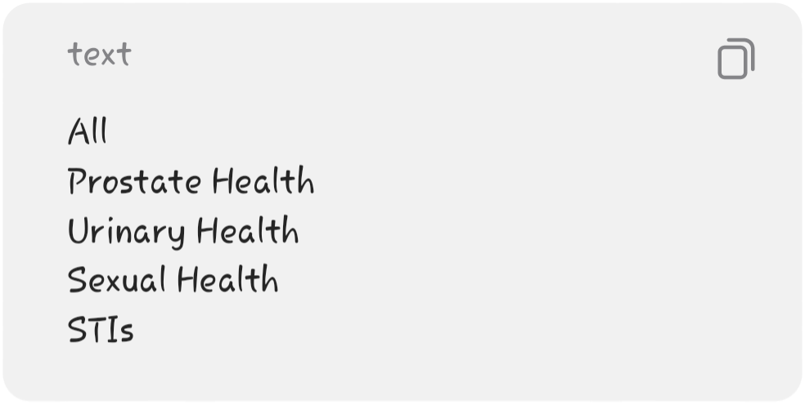

───
7. Healthcare Service Requirements
UR-12: Find Healthcare Services
The user should be able to access a directory of healthcare facilities.
The directory should help users identify facilities offering relevant services.

───

UR-13: Search by Location
The user should be able to search for healthcare facilities based on location.
For example:
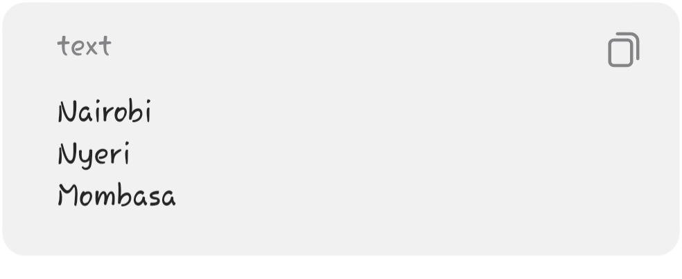

───

- UR-14: Filter by Healthcare Service
- The user should be able to filter facilities based on available services, such as:
- Urology
- STI Testing
- General Medical Care
Sexual & Reproductive Health
Emergency Care

───

- UR-15: View Facility Information
- The user should be able to select a facility and view information such as:
- Facility name
- Location
- Address
- Contact information
- Services provided
Opening hours, where available
Location/directions

───

UR-16: Get Directions
Where location information is available, the user should be able to access directions to a healthcare facility through an appropriate mapping service.
───

8. Health Awareness Requirements
UR-17: View Health Facts
The user should be able to view short educational health facts.
For example:
Did You Know?
Some sexually transmitted infections may cause few or no noticeable symptoms.
The feature should make learning quick and engaging.

───

UR-18: View Myth vs Fact
The user should be able to access information addressing common misconceptions about men's health.
The information should clearly distinguish between:
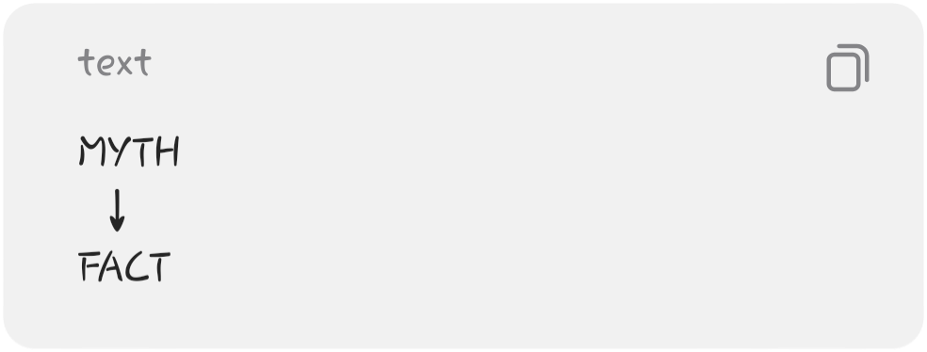
The user should be able to navigate through multiple myth-and-fact entries.

───

9. Privacy Requirements
UR-19: Browse Privately
The user should be able to access general health information without creating a personal account.

───

- UR-20: Minimize Personal Information
- The user should not be required to provide unnecessary personal information such as:
- Full name
- National identification number
Phone number
Email address
to access educational content.

───
UR-21: Understand Privacy Practices
The user should be able to access a privacy page explaining how the platform handles information and what information it does and does not collect.

───

10. Medical Information Requirements
UR-22: Access a Medical Disclaimer
The user should be able to see a clear disclaimer explaining that MenCare Health Hub is an educational platform.
The system should communicate that:
The information provided is for educational purposes and does not replace professional
medical examination, diagnosis, testing, or treatment.

───

UR-23: No Self-Diagnosis
The user should not be given a result stating that they have a particular disease based solely on information entered or symptoms selected on the platform.
The system should use wording such as:
"This symptom may be associated with several conditions."
rather than:
"You have UTI."

───
UR-24: Access Professional Healthcare Information
When appropriate, users should be directed toward professional healthcare services rather than being provided with personalized treatment instructions.

───

11. Usability Requirements
UR-25: Simple Navigation
The user should be able to easily navigate between:
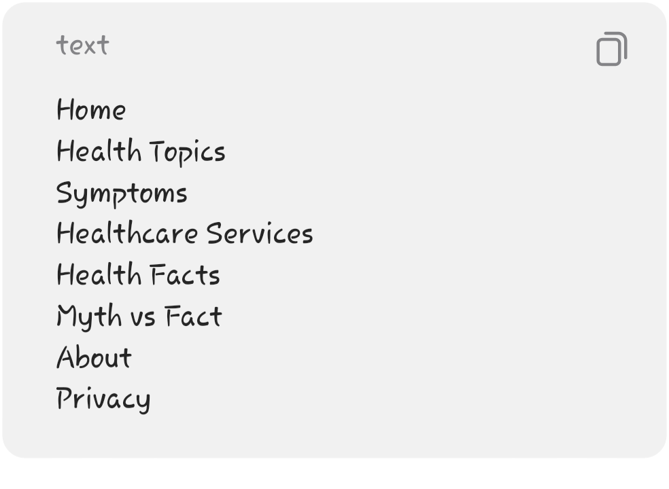

───

- UR-26: Easy-to-Understand Content
- The health information should:
- Use simple language
- Avoid unnecessary medical jargon
Use headings and subheadings
Use bullet points where appropriate
Break long information into sections

───
UR-27: Mobile Accessibility
The user should be able to use the platform effectively on a smartphone.
The interface should adapt to different screen sizes.

───

UR-28: Consistent Interface
Similar information should be displayed consistently.
For example, every condition page should follow a similar structure:

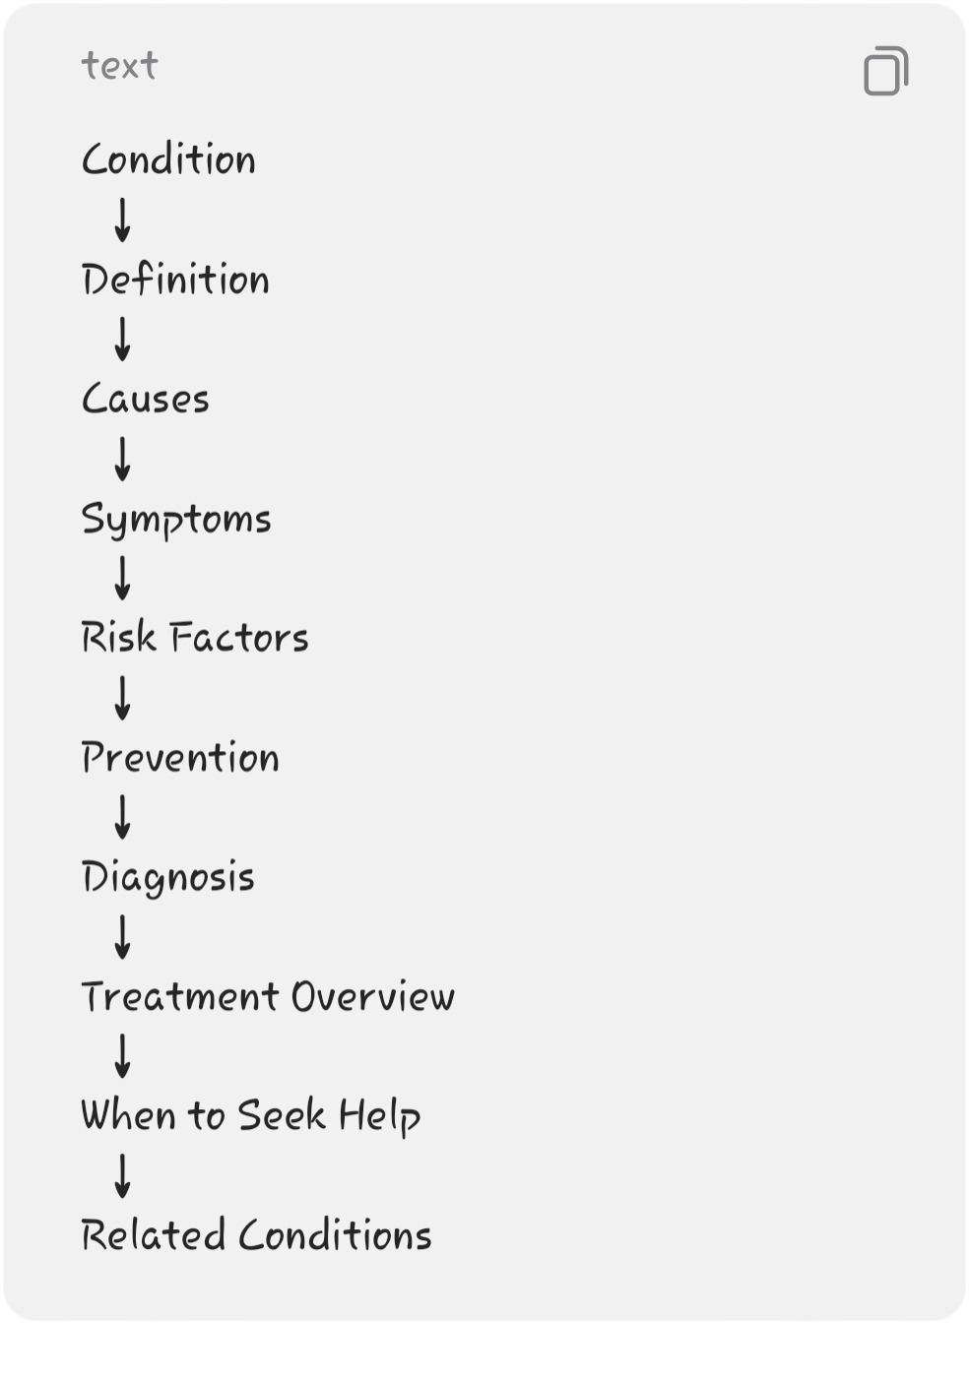

───

12. Administrator User
Requirements
UR-29: Administrator Login
The administrator should be able to securely log into the administrative section.
The public should not have access to administrative functionality.

- ───

- UR-30: Manage Health Conditions
- The administrator should be able to:
Add a condition
View conditions
Edit a condition
Delete a condition
- ───

- UR-31: Manage Health Categories
- The administrator should be able to:
Add categories
View categories
Edit categories
Delete categories

- ───

- UR-32: Manage Health Facts
- The administrator should be able to:
Add health facts
View health facts
Edit health facts
Delete health facts

- ───

- UR-33: Manage Myth vs Fact
- The administrator should be able to:
Add myth/fact content
Edit existing content
Delete content
View existing content

- ───

- UR-34: Manage Healthcare Facilities
- The administrator should be able to:
Add healthcare facilities
View facilities
Edit facility information
Delete facilities

───

13. Administrator Dashboard Requirements
UR-35: View System Summary
After logging in, the administrator should be able to see a simple summary of the platform.
For example:

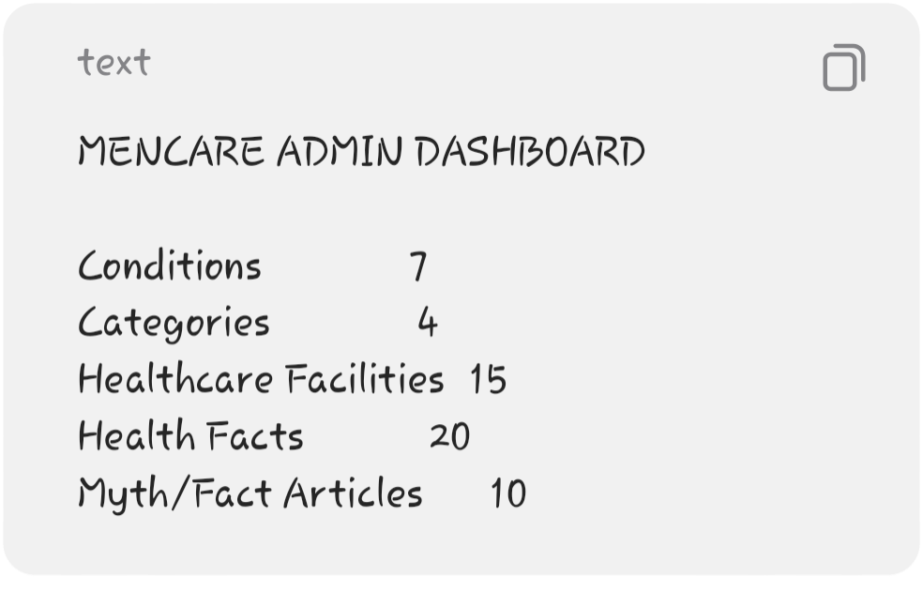

- ───

- 14. User Experience Requirements
- The system should provide a comfortable experience for users dealing with potentially sensitive health topics.
- The interface should:
- Avoid judgmental language
- Use respectful terminology
Avoid unnecessarily alarming messages
Maintain a professional appearance
Provide clear navigation
Make sensitive information easy to find
Avoid requiring unnecessary personal information

- ───

- 15. Accessibility Requirements
- The platform should consider users with different abilities.
- The system should:
- Provide readable text
- Maintain sufficient contrast
Use descriptive labels
Avoid relying solely on color to communicate information
Provide clear buttons and navigation
Support keyboard navigation where practical
Use appropriate headings and page structure

───

16. User Expectations
Users expect MenCare Health Hub to be:
Easy to Use
Users should not require technical knowledge to navigate the website.
Informative
Information should be relevant, structured, and understandable.
Private
Users should be able to browse sensitive health
information without being forced to create an account.
Reliable
Health information should be reviewed and sourced from credible medical/health authorities before publication.
Accessible
The system should work on commonly used devices, particularly smartphones.
Non-Judgmental
The platform should present sensitive men's health topics in a respectful manner.

───
17. User Requirements Summary

Requirement | General User | Administrator
Access Homepage | ✓ | ✓
Browse Health Topics | ✓ | ✓
View Conditions | ✓ | ✓
View Symptoms | ✓ | ✓
Search Health Information | ✓ | ✓
View Health Facts | ✓ | ✓
View Myth vs Fact | ✓ | ✓
Find Healthcare Facilities | ✓ | ✓
Search Facilities | ✓ | ✓
View Facility Details | ✓ | ✓
Administrator Login | — | ✓
Add Conditions | — | ✓
Edit Conditions | — | ✓
Delete Conditions | — | ✓
Manage Categories | — | ✓
Manage Health Facts | — | ✓
Manage Myth/Fact | — | ✓
Manage Healthcare Facilities | — | ✓

───

18. Main User Journey
The primary user experience can be summarized as:
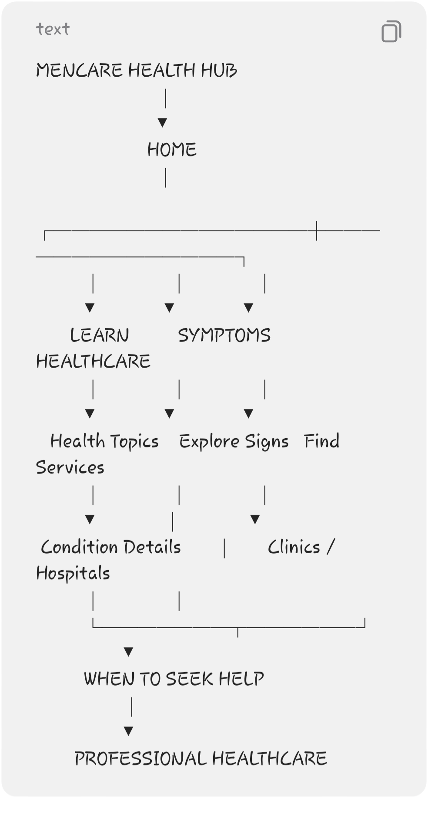

───

19. Final User Requirement
The most important requirement of the system is that:
Users should be able to privately and easily learn about men's urological and reproductive health conditions, understand common symptoms and prevention measures, and locate appropriate healthcare services without the system attempting to diagnose or treat them.
This keeps the user requirements aligned with the MVP and clearly separates health education and healthcare navigation from medical diagnosis.

